**Programable mirror folding automat (Civic 8th gen)**

8-in

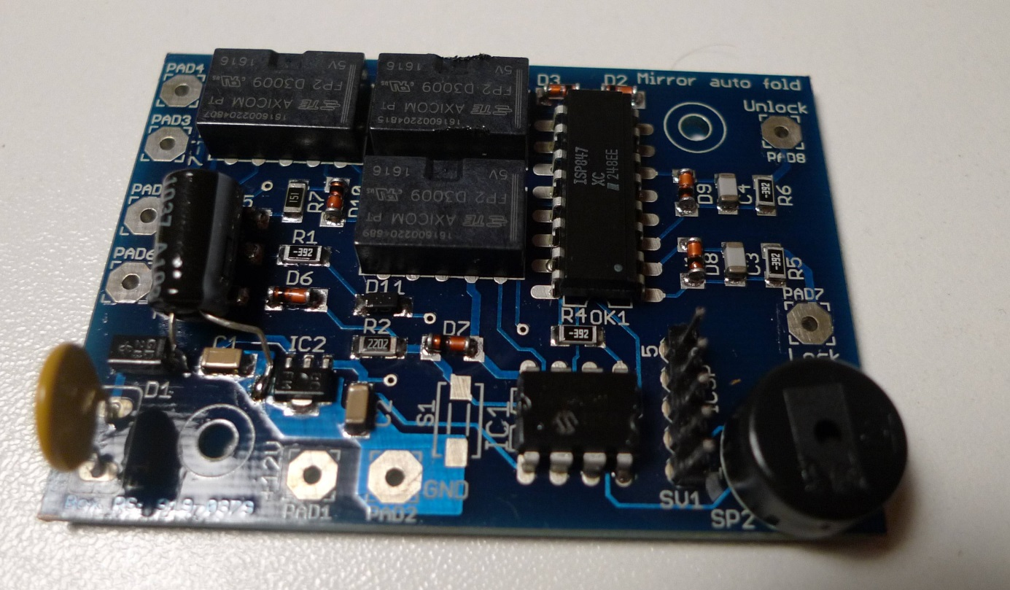

Lock-In

Unlock-In

GND

+12V

7-out

8-out

7-in

|  |  |  |
| --- | --- | --- |
| **Pin** | **Function** | **Connected to ...** |
| GND | Ground (-) | Y connector |
| +12V | Power supply 12V (permanent) | 12V power supply on the window connector |
| 8 - inch | Pin 8 from the female connector – signal from the mirror switch.  If 12V appears at that input, it signals that the contact is ON.  The same input detects whether the mirror switch is pressed. If the input is connected to ground (GND), the switch is pressed. | Y connector |
| 7 - inch | Pin 7 from the female connector - signal from the mirror switch.  If 12V appears at that input, it signals that the contact is ON. | Y connector |
| 8 - out | Pin 8 from male connector, output to mirrors | Y connector |
| 7 - out | Pin 7 from male connector, output to mirrors | Y connector |
| Lock-in | Lock signal input, 12V active | Central connector |
| Unlock - in | Unlock signal input, 12V active | Central connector |

The Lock and Unlock signals are filtered from interference in the controller's SW, 80 ms debouncing time means that the signal must be active for a minimum of 80 ms without interruption in order to be processed.

The "8-in" mirror switch signal is filtered in the controller SW, 200 ms debouncing time means that the switch must spend a minimum of 200 ms in any state (down or up) to be processed correctly, otherwise it is ignored (noisy protection or bad switching action from switch itself).

Automat wiring

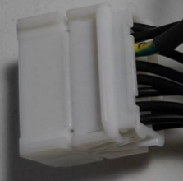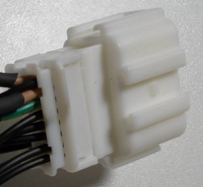

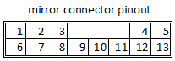



Central lock plug inside driver door

Window plug inside driver door – take permanent 12V supply

FN/FK – pin 15

FD – pin 4.

Check on yours

Unlock

Lock

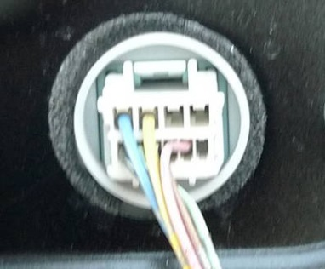

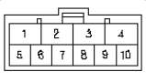

Central lock plug

Noticed some missmatch in pinouts.

According to service documentation:

3 – Lock ; 4 – Unlock

Image on left is situation on my car, check on yours.

**Function testing on table**

Central lock plug

According to service manual, +12V is shortly present on: Lock – pin 3 ; Unlock – pin4.

But not in my case (see left picture)

1. - connect 12V power supply (+12V and GND), do not connect anything to the other inputs, the controller makes short sounds, the number corresponds to the saved program.
2. – supply 12V to the Lock or Unlock input (1x or 2x), according to the set program, the controller energise relays and performs the action of unfolding or folding the mirrors, the voltage is present at the "7-out" and "8-out" outputs and lasts for 10 seconds.

The output voltage is set according to this scheme depending on the action

|  |  |  |
| --- | --- | --- |
|  | **7-out** | **8-out** |
| **Fold** | + 12V | GND |
| **Unfold** | GND | +12V |

Actions depending on the program

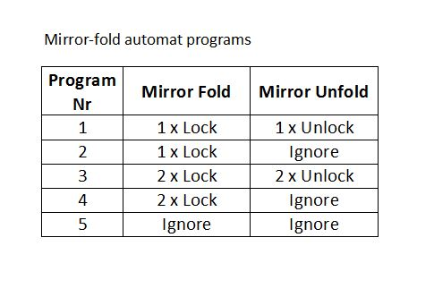

If a buzzer sounds instead of the desired action, it means that one of the conditions is not met:

1 x buzzer - the selected program does not support this action, the command is ignored (program 2, 4 or 5)

2 x buzzing - mirror switch in down position ("8-in" connected to ground), command ignored.

1. Contact simulation, connect "7-in" or "8-in" to +12V
2. Simulation of the mirror switch in the folded position (down position), connect the "8-in" to ground

Changing the program

* Turn on and off the ignition (connect the "7-in" or "8-in" to 12V and then disconnect the 12V)
* Within 3 seconds, start pressing the mirror button ("8-in" connect to ground and disconnect), after the third press, the buzzer will sound a two-tone sound TU-TII
* After that, the buzzer counts down the number of times according to the currently recorded program number and ends with TU-TII.
* Start pressing the mirror button ("8-in" connect to ground and disconnect) as many times as you want to select a new program
* The buzzer sounds TU-TII and then repeats the number of the new program that was recorded and ends with TU-TII.

Notes:

The Lock/Unlock and “8-in” inputs are debounce filtered, 80 ms (Lock/Unlock) and 200 ms “8-in”.

This means that the signal at these inputs must be high without interruption for a minimum of that time in order to be processed, otherwise it is ignored (it is considered interference). Pay special attention to this when simulating the rearview mirror switch, that the contact (connection to ground) is permanent for a minimum of 200ms.

If the buzzer sounds with the tone TI-TUU (higher then lower tone) when changing the program, this means that programming has been interrupted, too much time has passed since the moment when a new program should have been set (the rearview mirror button was not pressed / the "8-in" was not connected to ground) or the wrong program number has been set (button pressed more than 5 times => non-existent program).

PCB overview

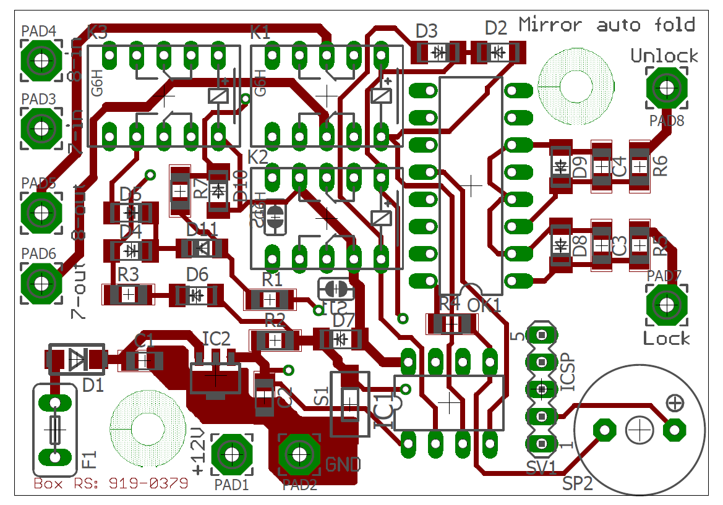

All SMD capacitors and resistors are 1206 (inch) size, capacitors minimum 25V.

Relays: TE FP2 or IM03TS (5V coil)

PCB is designed to fit in enclosure RS PRO : 919-0335 or 919-0379 (RS PRO ABS Enclosure, Flanged, Black Lid, 70 x 50 x 29mm)

Switch S1 is not needed, it can be used for settings programs during functionality test

For sound device (SP2) use speaker, not buzzer!! Since controller modulate 2 tone sounds it must be speaker.

Specials connectors for Y-wire harness (red circle) I could not found on internet, I bought some existing mirror module from internet (For civic 8 gen which I didn’t like how it functions) and took connectors from it to assemble my harness. Finding this connectors could be most challenging for you, but I don’t like to cut wires on existing installation so I get this connectors as I only could.

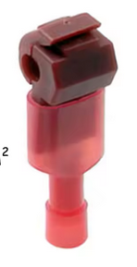Connectors in blue circles are standard wire terminals that can be hooked directly on wire without cutting (search Aliexpress for “T-type Wire Connector Quick Electrical Terminal Crimp“

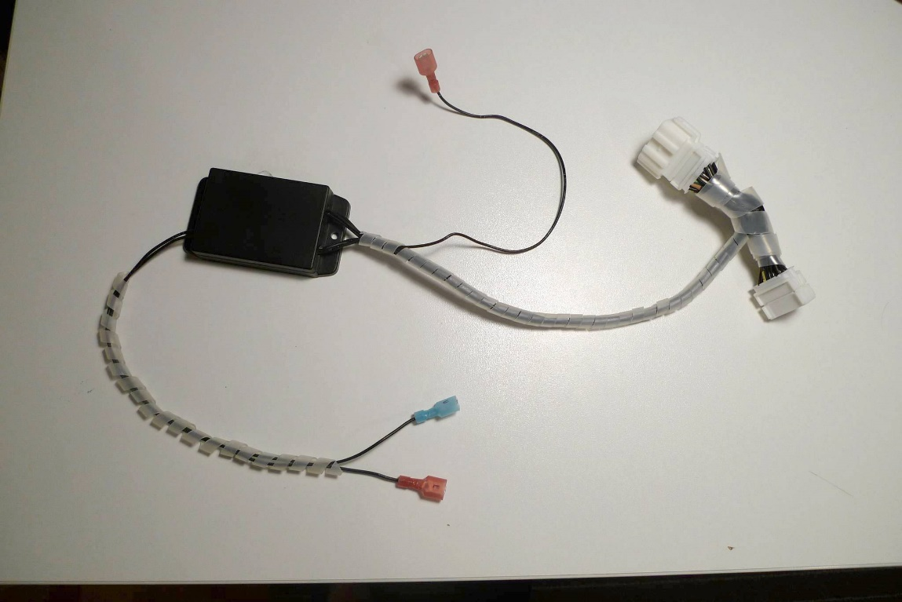

Demonstration video: <https://youtu.be/eVyPs17ZJMc> (zokonjazokonja@gmail.com)